MACHINE LEARNING LAB-01

PART A – NUMPY
Q1. Create a NumPy array containing the integers from 1 to 20.
Perform the following operations:
- Display the array.
- Find the shape of the array.
- Find the maximum and minimum values.
- Calculate the mean and standard deviation.
- Reshape the array into a 4 × 5 matrix.
- Display the second row of the matrix.
- Display the third column of the matrix.

CODE
import numpy as np
arr = np.arange(1, 21)
print("Array:")
print(arr)
print("\nShape:")
print(arr.shape)
print("\nMaximum Value:")
print(arr.max())
print("\nMinimum Value:")
print(arr.min())
print("\nMean:")
print(arr.mean())
print("\nStandard Deviation:")
print(arr.std())
matrix = arr.reshape(4, 5)
print("\n4x5 Matrix:")
print(matrix)
print("\nSecond Row:")
print(matrix[1])
print("\nThird Column:")
print(matrix[:, 2])

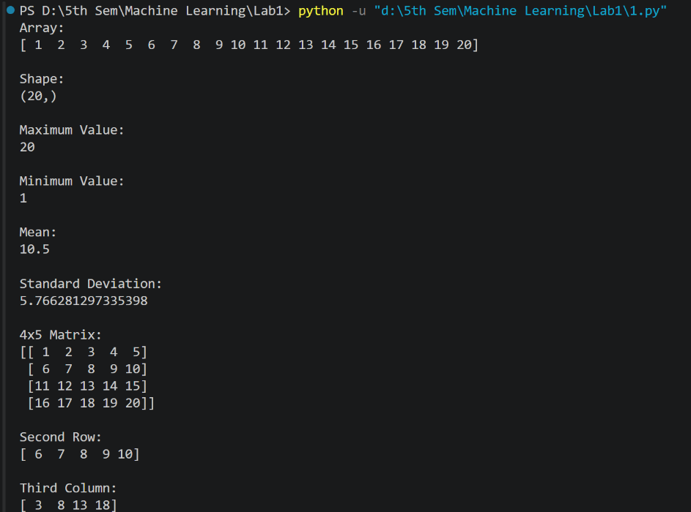
OUTPUT

Q2. Create two NumPy arrays:
A = [10, 20, 30, 40, 50]
B = [5, 10, 15, 20, 25]
Perform:
- Addition of A and B.
- Subtraction of B from A.
- Element-wise multiplication.
- Element-wise division.
- Find the sum of all elements in A

CODE
import numpy as np
A = np.array([10, 20, 30, 40, 50])
B = np.array([5, 10, 15, 20, 25])
print("Addition:")
print(A + B)
print("\nSubtraction:")
print(A - B)
print("\nElement-wise Multiplication:")
print(A * B)
print("\nElement-wise Division:")
print(A / B)
print("\nSum of Elements in A:")
print(np.sum(A))

OUTPUT

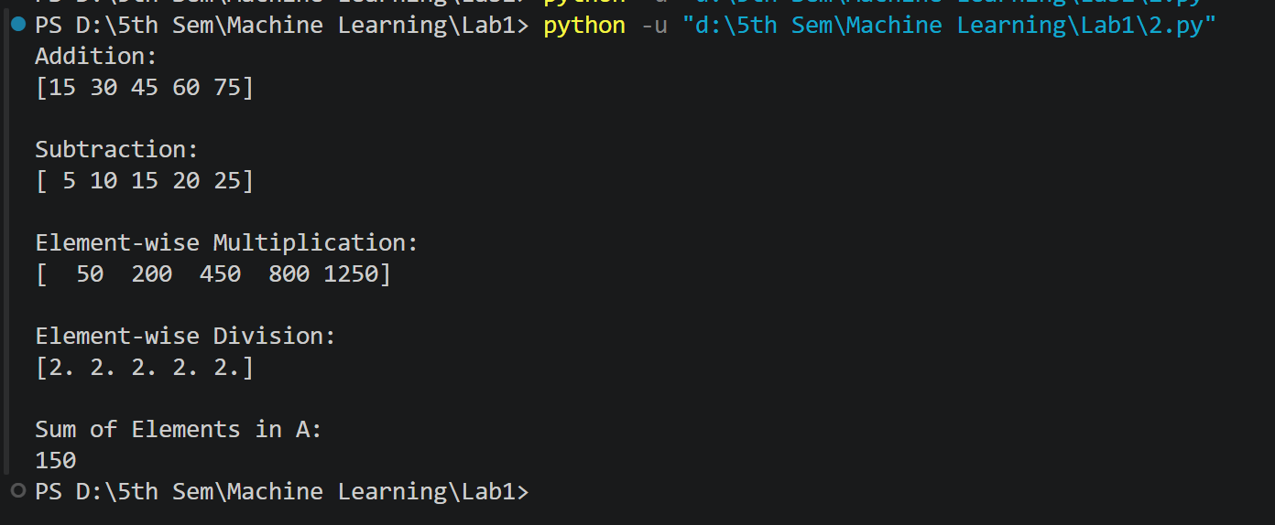

PART B – PANDAS

3. Create a DataFrame using the following student data:
Roll No Name Marks
101 Ravi 85
102 Priya 92
103 Kiran 78
104 Anu 88
105 Sita 95
Perform the following operations:
- Display the DataFrame.
- Display the first three records.
- Find the average marks.
- Find the student with the highest marks.
- Find the student with the lowest marks.
- Add a new column called "Grade" using:
A for Marks ≥ 90
B for Marks between 80 and 89
C for Marks < 80

CODE
import pandas as pd
data = {
"Roll No": [101, 102, 103, 104, 105],
"Name": ["Ravi", "Priya", "Kiran", "Anu", "Sita"],
"Marks": [85, 92, 78, 88, 95]
}
df = pd.DataFrame(data)
print("DataFrame:")
print(df)
print("\nFirst Three Records:")
print(df.head(3))
print("\nAverage Marks:")
print(df["Marks"].mean())
print("\nStudent with Highest Marks:")
print(df.loc[df["Marks"].idxmax()])
print("\nStudent with Lowest Marks:")
print(df.loc[df["Marks"].idxmin()])
def grade(mark):
if mark >= 90:
return "A"
elif mark >= 80:
return "B"
else:
return "C"
df["Grade"] = df["Marks"].apply(grade)
print("\nDataFrame with Grade:")
print(df)

OUTPUT
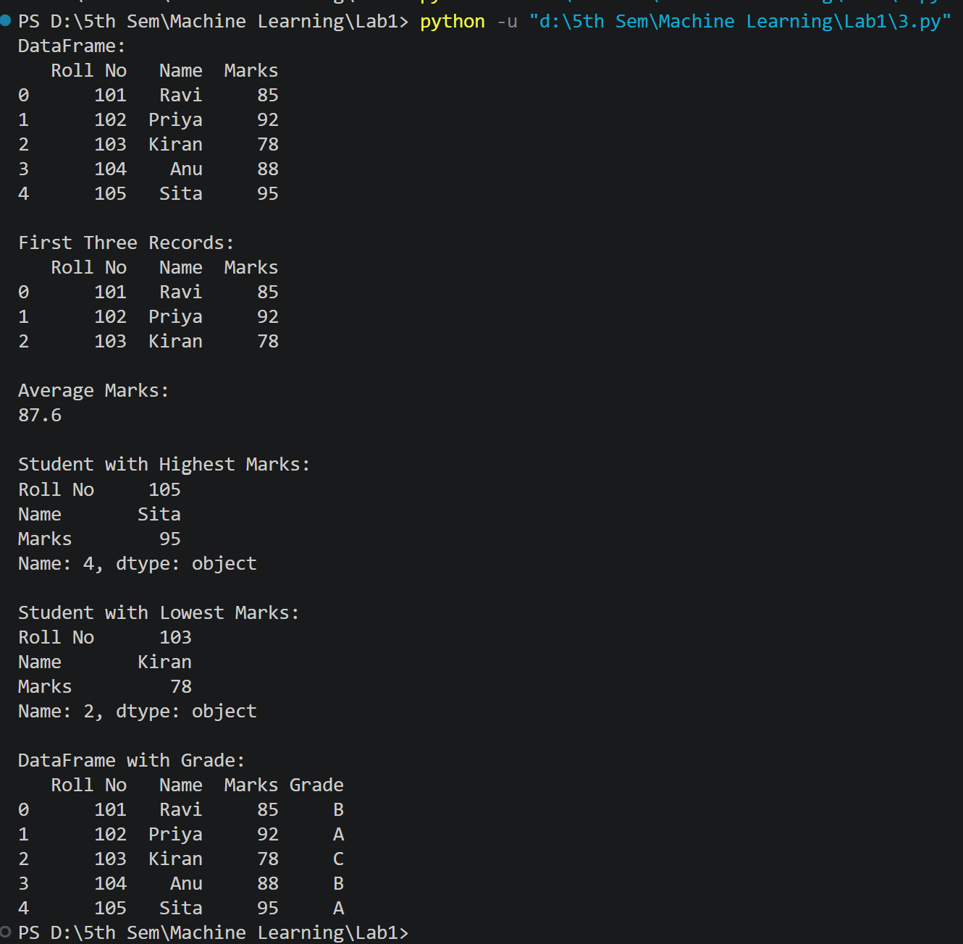

Q4. Create a DataFrame containing the following information:
Product Price Quantity
Laptop 50000 10
Mouse 500 50
Keyboard 1200 30
Monitor 10000 15
Perform:
- Calculate the total value of each product using:
Total Value = Price × Quantity
- Add the Total Value column.
- Find the product with the highest total value.
- Calculate the overall inventory value.

CODE
import pandas as pd
data = {
"Product": ["Laptop", "Mouse", "Keyboard", "Monitor"],
"Price": [50000, 500, 1200, 10000],
"Quantity": [10, 50, 30, 15]
}
df = pd.DataFrame(data)
df["Total Value"] = df["Price"] * df["Quantity"]
print("DataFrame:")
print(df)
print("\nProduct with Highest Total Value:")
print(df.loc[df["Total Value"].idxmax()])
print("\nOverall Inventory Value:")
print(df["Total Value"].sum())

OUTPUT
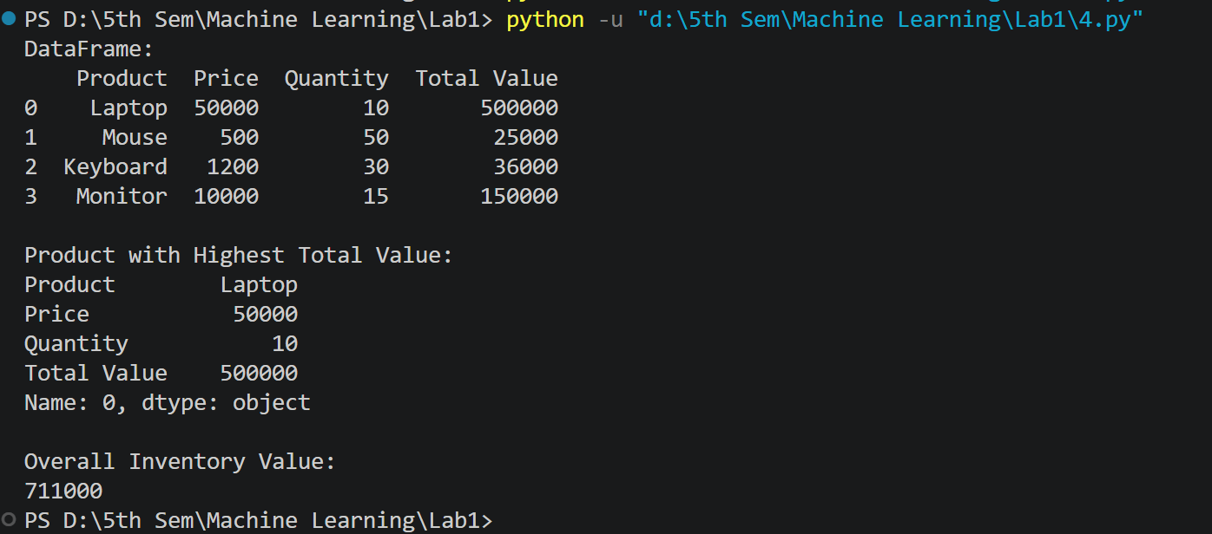

PART C – DATASET EXPLORATION

Q5. Download the Iris dataset from Scikit-learn and perform the following:
- Load the dataset into a Pandas DataFrame.
- Display the first five records.
- Find the number of rows and columns.
- Display column names.
- Check for missing values.
- Generate summary statistics using describe().
- Find the number of samples belonging to each class.

CODE
from sklearn.datasets import load_iris
import pandas as pd
iris = load_iris()
df = pd.DataFrame(
iris.data,
columns=iris.feature_names
)
df["target"] = iris.target
print("First Five Records:")
print(df.head())
print("\nNumber of Rows and Columns:")
print(df.shape)
print("\nColumn Names:")
print(df.columns)
print("\nMissing Values:")
print(df.isnull().sum())
print("\nSummary Statistics:")
print(df.describe())
print("\nSamples in Each Class:")
print(df["target"].value_counts())

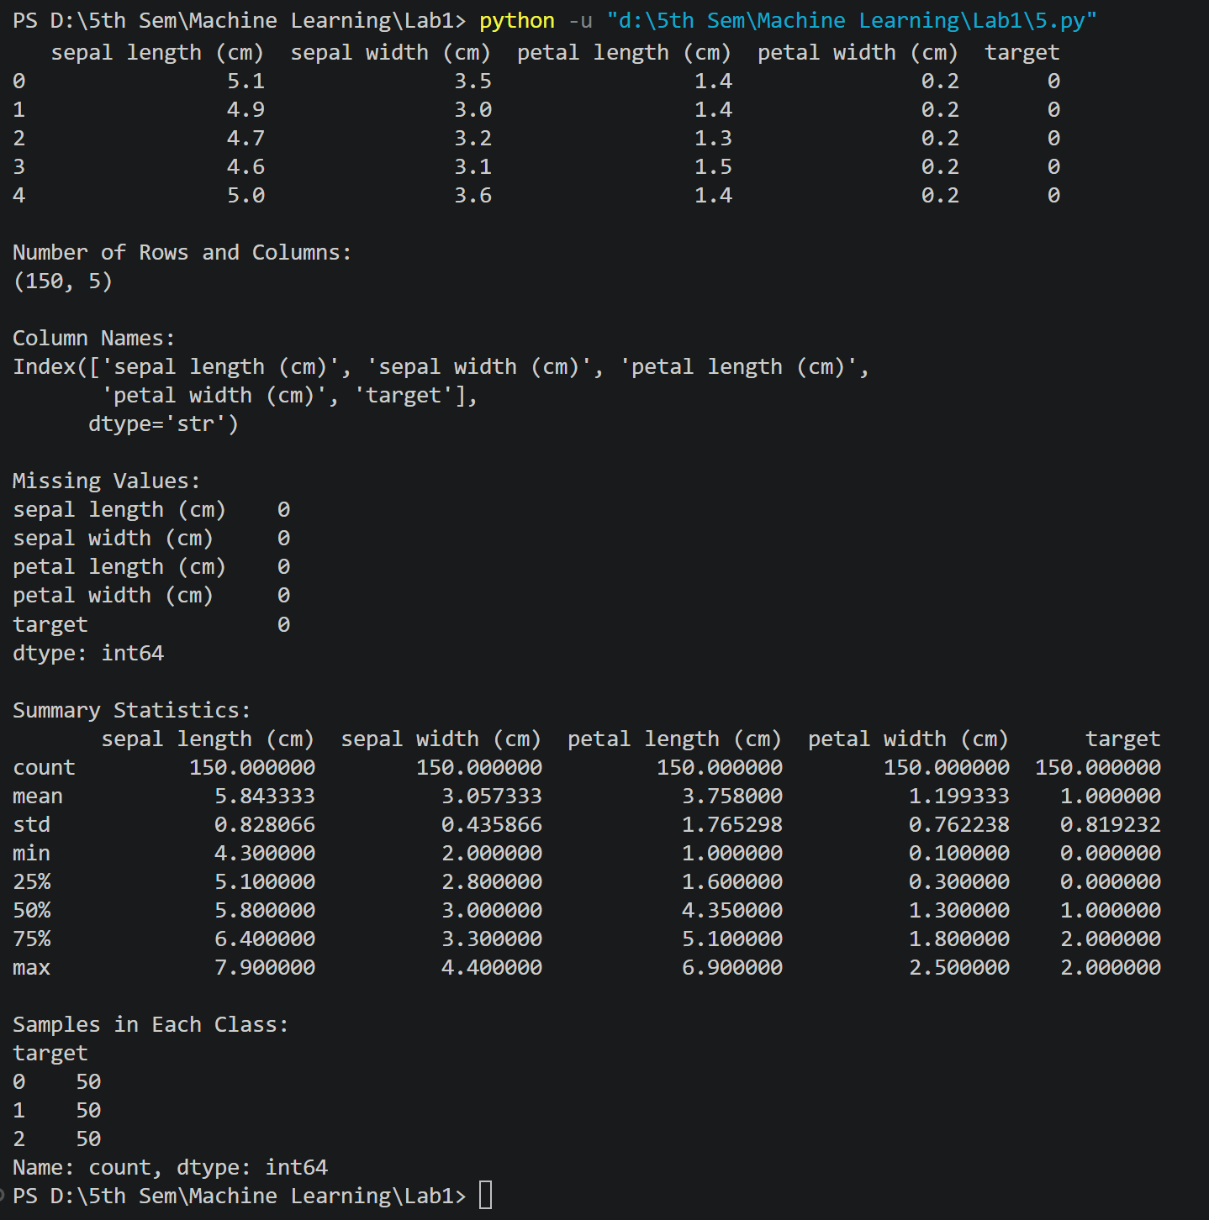
OUTPUT

LAB 02

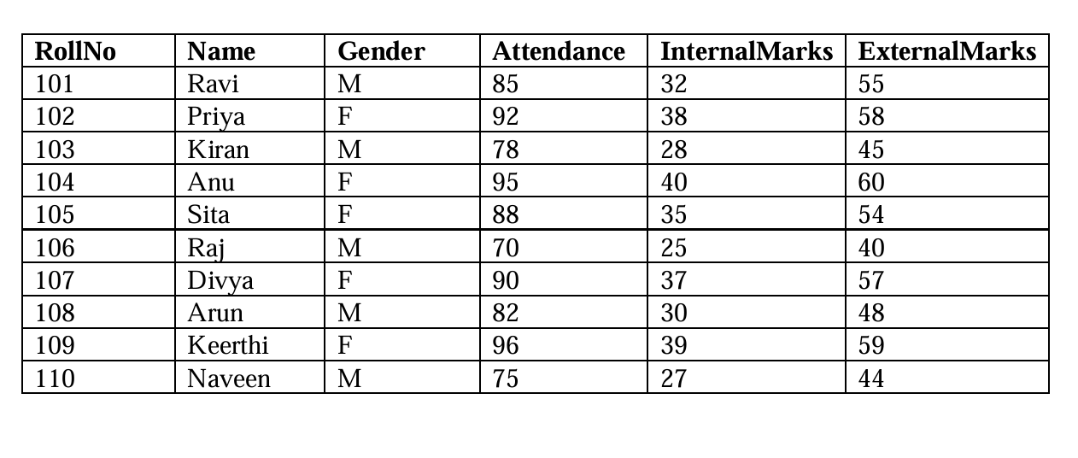
Create a CSV file named student_data.csv with the following data:
Task A: Dataset Loading and Inspection
- Import the necessary Python libraries.
- Load the dataset into a Pandas DataFrame.
- Display the first five records.
- Display the last five records.
- Find the total number of rows and columns.
- Display the names of all columns.
- Display the data type of each column.
- Generate dataset information using info().
Task B: Statistical Analysis
- Calculate the mean attendance of all students.
- Calculate the average Internal Marks.
- Calculate the average External Marks.
- Find the maximum Internal Marks.
- Find the minimum Internal Marks.
- Find the maximum External Marks.
- Find the minimum External Marks.
- Calculate the standard deviation of Internal Marks.
- Generate summary statistics using describe().
Task C: Data Manipulation
- Create a new column named TotalMarks.
- TotalMarks = InternalMarks + ExternalMarks
- Create a new column named Percentage.
- Percentage = TotalMarks / 100 × 100
- Display the updated DataFrame.

Task D: Filtering and Searching
- Display the details of students whose attendance is greater than 90%.
- Display the details of students whose TotalMarks exceed 90.
- Display the details of female students.
- Display the details of male students.
- Display students whose ExternalMarks are less than 50.

Task E: Ranking and Comparison
- Identify the student with the highest TotalMarks.
- Identify the student with the lowest TotalMarks.
- Display the top three performers based on TotalMarks.
- Display the bottom three performers based on TotalMarks.
- Determine how many students scored above the class average.
Task F: Group-wise Analysis
- Calculate the average TotalMarks of male students.
- Calculate the average TotalMarks of female students.
- Compare the average attendance of male and female students.
Task G: Data Visualization
- Plot a bar chart showing TotalMarks of all students.
- Plot a histogram of Attendance.
- Plot a pie chart showing the distribution of male and female students.
- Plot a scatter plot between Attendance and TotalMarks.
- Interpret the relationship between Attendance and TotalMarks.
Task H: Observations
- Write any three observations based on the analysis performed.
- State whether higher attendance appears to be associated with better academic performance.

CODE

import pandas as pd
import matplotlib.pyplot as plt

# Task A

df = pd.read_csv("student_data.csv")

print("\nFIRST FIVE RECORDS")
print(df.head())

print("\nLAST FIVE RECORDS")
print(df.tail())

print("\nROWS AND COLUMNS")
print(df.shape)

print("\nCOLUMN NAMES")
print(df.columns)

print("\nDATA TYPES")
print(df.dtypes)

print("\nDATASET INFORMATION")
print(df.info())

# Task B

print("\nMean Attendance:", df["Attendance"].mean())
print("Average Internal Marks:", df["InternalMarks"].mean())
print("Average External Marks:", df["ExternalMarks"].mean())

print("Maximum Internal Marks:", df["InternalMarks"].max())
print("Minimum Internal Marks:", df["InternalMarks"].min())

print("Maximum External Marks:", df["ExternalMarks"].max())
print("Minimum External Marks:", df["ExternalMarks"].min())

print("Standard Deviation of Internal Marks:",
df["InternalMarks"].std())

print("\nSummary Statistics")
print(df.describe())

# Task C

df["TotalMarks"] = df["InternalMarks"] + df["ExternalMarks"]

df["Percentage"] = (df["TotalMarks"] / 100) * 100

print("\nUPDATED DATAFRAME")
print(df)

# Task D

print("\nAttendance > 90")
print(df[df["Attendance"] > 90])

print("\nTotal Marks > 90")
print(df[df["TotalMarks"] > 90])

print("\nFemale Students")
print(df[df["Gender"] == "F"])

print("\nMale Students")
print(df[df["Gender"] == "M"])

print("\nExternal Marks < 50")
print(df[df["ExternalMarks"] < 50])

# Task E

print("\nHighest Total Marks Student")
print(df.loc[df["TotalMarks"].idxmax()])

print("\nLowest Total Marks Student")
print(df.loc[df["TotalMarks"].idxmin()])

print("\nTop Three Performers")
print(df.nlargest(3, "TotalMarks"))

print("\nBottom Three Performers")
print(df.nsmallest(3, "TotalMarks"))

class_average = df["TotalMarks"].mean()

print("\nStudents Above Class Average")
print((df["TotalMarks"] > class_average).sum())

# Task F

print("\nAverage Total Marks of Male Students")
print(df[df["Gender"] == "M"]["TotalMarks"].mean())

print("\nAverage Total Marks of Female Students")
print(df[df["Gender"] == "F"]["TotalMarks"].mean())

print("\nAverage Attendance by Gender")
print(df.groupby("Gender")["Attendance"].mean())

# Task G

# Bar Chart
plt.figure(figsize=(8,5))
plt.bar(df["Name"], df["TotalMarks"])
plt.title("Total Marks of Students")
plt.xlabel("Student Name")
plt.ylabel("Total Marks")
plt.show()

# Histogram
plt.figure(figsize=(6,5))
plt.hist(df["Attendance"], bins=5)
plt.title("Attendance Distribution")
plt.xlabel("Attendance")
plt.ylabel("Frequency")
plt.show()

# Pie Chart
gender_count = df["Gender"].value_counts()

plt.figure(figsize=(5,5))
plt.pie(gender_count,
labels=gender_count.index,
autopct="%1.1f%%")
plt.title("Gender Distribution")
plt.show()

# Scatter Plot
plt.figure(figsize=(6,5))
plt.scatter(df["Attendance"], df["TotalMarks"])
plt.title("Attendance vs Total Marks")
plt.xlabel("Attendance")
plt.ylabel("Total Marks")
plt.show()

print("\nInterpretation:")
print("Students with higher attendance generally tend to have higher total marks.")

# Task H

print("\nOBSERVATIONS")
print("1. Female students have slightly higher average marks than male students.")
print("2. Students with attendance above 90% generally score better.")
print("3. Higher attendance appears to be associated with better academic performance.")

LAB-03 ID3 algorithm

import math
from collections import Counter

def entropy(labels):
total = len(labels)
counts = Counter(labels)
ent = 0
for count in counts.values():
p = count / total
ent -= p * math.log2(p)
return ent

def information_gain(X, y, feature_index):

# Entropy of complete dataset
total_entropy = entropy(y)
# Find unique values of the selected feature
values = set()
for row in X:
values.add(row[feature_index])
weighted_entropy = 0

# Calculate entropy for each split
for value in values:

sub_y = []

# Collect class labels belonging to this value
for i in range(len(X)):
if X[i][feature_index] == value:
sub_y.append(y[i])

weight = len(sub_y) / len(y)
weighted_entropy = weighted_entropy + weight * entropy(sub_y)
information_gain = total_entropy - weighted_entropy
return information_gain

# ID3 Algorithm
def id3(X, y, features):

# Step 1: If all labels are same
if len(set(y)) == 1:
return y[0]
# Step 2: No features left
if not features:
return Counter(y).most_common(1)[0][0]

# Step 3 & 4: Calculate Information Gain
gains = {}
for feature in features:
gains[feature] = information_gain(X, y, feature)

# Step 5: Best Feature
best_feature = max(gains, key=gains.get)

# Step 6: Create Node
tree = {best_feature: {}}

# Step 7: Split Dataset
values = set()

for row in X:
values.add(row[best_feature])

for value in values:

X_sub = []
y_sub = []

for i in range(len(X)):
if X[i][best_feature] == value:
X_sub.append(X[i])
y_sub.append(y[i])

remaining_features = features.copy()
remaining_features.remove(best_feature)

tree[best_feature][value] = id3(
X_sub,
y_sub,
remaining_features
)

return tree

def predict(tree, sample):
# Keep checking until we reach a leaf
while isinstance(tree, dict):
# Get the feature at the current node
for feature in tree:
break

# Get the sample's value for that feature
value = sample[feature]

# Move to the next branch if it exists
if value in tree[feature]:
tree = tree[feature][value]
else:
return "Unknown"

# When tree is no longer a dictionary, it is the prediction
return tree

# Dataset

X_train = [
['Y', 'High', 'no', 'fair'],
['Y', 'High', 'no', 'excellent'],
['M_A', 'High', 'no', 'fair'],
['S', 'medium', 'no', 'fair'],
['S', 'low', 'yes', 'fair'],
['S', 'low', 'yes', 'excellent'],
['M_A', 'low', 'yes', 'excellent'],
['Y', 'medium', 'no', 'fair'],
['Y', 'low', 'yes', 'fair'],
['S', 'medium', 'yes', 'fair'],
['Y', 'medium', 'yes', 'excellent'],
['M_A', 'medium', 'no', 'excellent'],
['M_A', 'High', 'yes', 'fair'],
['S', 'medium', 'no', 'excellent']
]

y_train = [
'no', 'no', 'yes', 'yes',
'yes', 'no', 'yes', 'no',
'yes', 'yes', 'yes', 'yes',
'yes', 'no'
]

# Feature indices
features = [0, 1, 2, 3]
# Build Tree
tree = id3(X_train, y_train, features)

print("Decision Tree:")
print(tree)

# Test Sample
test_sample = ['Y', 'low', 'yes', 'fair']

prediction = predict(tree, test_sample)

print("\nPrediction:", prediction)

OUTPUT

LAB -04 Naïve Bayes Algorithm

X_train = [
['Y', 'High', 'no', 'fair'],
['Y', 'High', 'no', 'excellent'],
['M_A', 'High', 'no', 'fair'],
['S', 'medium', 'no', 'fair'],
['S', 'low', 'yes', 'fair'],
['S', 'low', 'yes', 'excellent'],
['M_A', 'low', 'yes', 'excellent'],
['Y', 'medium', 'no', 'fair'],
['Y', 'low', 'yes', 'fair'],
['S', 'medium', 'yes', 'fair'],
['Y', 'medium', 'yes', 'excellent'],
['M_A', 'medium', 'no', 'excellent'],
['M_A', 'high', 'yes', 'fair'],
['S', 'medium', 'no', 'excellent']
]
y_train = ['no', 'no', 'yes', 'yes', 'yes', 'no', 'yes', 'no', 'yes', 'yes', 'yes', 'yes', 'yes', 'no']
test_sample = ['Y', 'low', 'yes', 'fair']

total_rows = len(y_train)
total_features = len(test_sample)

print(f"Evaluating test sample: {test_sample}\n")

#finding no of unique class
unique_classes = []
for label in y_train:
if label not in unique_classes:
unique_classes.append(label)

best_class = None
highest_score = 0

#no. of uniques class present
for current_class in unique_classes:
class_count = 0
for label in y_train:
if label == current_class:
class_count = class_count + 1

class_prior = class_count / total_rows #prior prob
print(f"--- Processing Class: '{current_class}' (Occurrences: {class_count}/{total_rows}) ---")
print(f" P(Class='{current_class}') = {class_prior:.4f}")

running_likelihood_product = 1.0 #prod h

for col_idx in range(total_features):
feature_match_count = 0
test_value = test_sample[col_idx]

for row_idx in range(total_rows):
if y_train[row_idx] == current_class: #current class == loop class
dataset_val = X_train[row_idx][col_idx].lower()
query_val = test_value.lower()

if dataset_val == query_val:
feature_match_count = feature_match_count + 1

feature_probability = feature_match_count / class_count
print(f" P(Feature_{col_idx}='{test_value}' | '{current_class}') = {feature_match_count} / {class_count} = {feature_probability:.4f}")
running_likelihood_product *= feature_probability

final_score = class_prior * running_likelihood_product
print(f" Final Score for '{current_class}': {final_score:.6f}\n")

if final_score > highest_score:
highest_score = final_score
best_class = current_class

print(f"Prediction: Test sample is classified as '{best_class}'")

OUTPUT
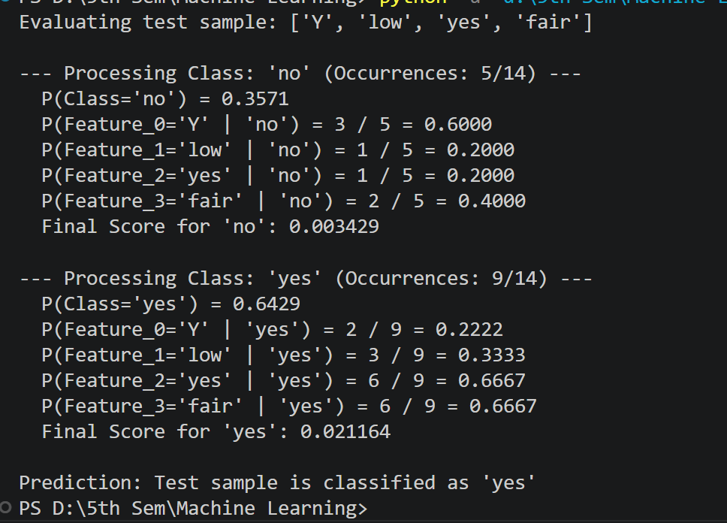

LAB 05
MARKOV NIKOV

CODE
# Initializing values

S = ["walk", "run", "rest"] # Hidden states
V = ["low", "med", "high"] # Observations

pi = [0.5, 0.3, 0.2] # Initial probabilities

A = [[0.6, 0.3, 0.1],
[0.2, 0.5, 0.3],
[0.3, 0.2, 0.5]]

B = [[0.6, 0.3, 0.1],
[0.1, 0.3, 0.6],
[0.7, 0.2, 0.1]]

O = ["high", "med", "low", "high"]

# Observation index
obs = {
"low": 0,
"med": 1,
"high": 2
}

alpha = []

first = []

for i in range(len(S)):
value = round(pi[i] * B[i][obs[O[0]]], 3)
first.append(value)

print(f"α1({S[i]}) = {pi[i]} x {B[i][obs[O[0]]]} = {value}")

alpha.append(first)

for t in range(1, len(O)):
print(f"\nObservation {t+1}: {O[t]}")
current = []
for j in range(len(S)):
total = 0
for i in range(len(S)):
total += alpha[t-1][i] * A[i][j]

value = round(total * B[j][obs[O[t]]], 3)
current.append(value)
print(f"α{t+1}({S[j]}) = {value}")
alpha.append(current)

print("\nAlpha Table")
for row in alpha:
print(row)

probability = round(sum(alpha[-1]), 3)
print("\nProbability of Observation Sequence =", probability)

OUTPUT
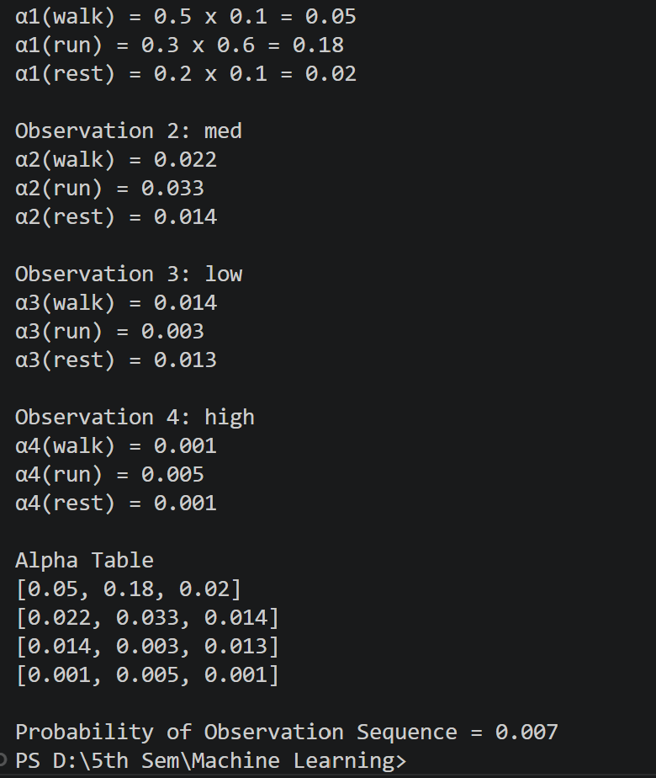

Task 2: Human Activity Recognition using hmmlearn
Problem Statement
Using the Hidden Markov Model parameters provided in Task 1, implement the HMM using the hmmlearn Python library.
Tasks
- Install the hmmlearn library and import the required modules.
- Construct a Categorical Hidden Markov Model using the given initial state probabilities, transition probability matrix, and emission probability matrix.
- Compute the likelihood of the observation sequence
O = (High, Medium, Low, High).
- Compute the likelihood for each of the following observation sequences:
  - O₁ = (Low, Medium, High, Medium)
  - O₂ = (High, High, High, High)
  - O₃ = (Low, Low, Low, Low)
  - O₄ = (Medium, Medium, Medium, Medium)
- Briefly explain the relationship between the observation likelihood computed using the Forward Algorithm and the likelihood obtained using hmmlearn.

#Using inbuilt libraries

!pip install hmmlearn

import numpy as np
from hmmlearn.hmm import CategoricalHMM

#Hidden States
S=input("Enter the hidden states:").split()

#Observation Symbol
V=input("Enter the Observation Symbol:").split()

#Initital States
Pi=[float(p) for p in input("Enter the initial states:").split()]

#State Transition Matrix
print()
A=[ [ 0 for _ in range (len(S))] for _ in range (len(S)) ]
for i in range(len(S)):
for j in range(len(S)):
A[i][j]=float(input(f"Enter transition probability from state {i+1} to {j+1}:"))

#Printing state transition matrix
print("\nState Transition Matrix:\n")
for i in range(len(S)):
for j in range (len(S)):
print(A[i][j],end=" ")
print()

#Emission Probability Matrix
print()
B=[ [ 0 for _ in range (len(V))] for _ in range (len(S)) ]
for i in range(len(S)):
for j in range(len(V)):
B[i][j]=float(input(f"Enter emission probability (P(O={V[j]}|S={S[i]})):"))

#Printing Emission matrix
print("\nEmission Probability Matrix:\n")
for i in range(len(S)):
for j in range (len(V)):
print(B[i][j],end=" ")
print()

# Create the HMM
model = CategoricalHMM(
n_components=len(S),
init_params=""
)

model.startprob_ = Pi
model.transmat_ = A
model.emissionprob_ = B

# Observation Mapping
obs_map = {symbol: index for index, symbol in enumerate(V)}

# Function to Compute Likelihood
def compute_likelihood(sequence):

X = np.array([[obs_map[x]] for x in sequence])

log_probability = model.score(X)
probability = np.exp(log_probability)

return probability

# Number of observation sequences
n = int(input("\nEnter the number of observation sequences: "))

for i in range(n):
sequence = input(f"\nEnter Observation Sequence {i+1}: ").split()
probability = compute_likelihood(sequence)
print(f"Likelihood of Sequence {i+1}: {probability:.10f}")

OUTPUT

